MGMT 443: New tool for managing new products

## The need for better new product management

* The single strongest predictor of investment value is dree of innovativeness of the company
* A typical industry relationship
  + How innovativeness impacts on investment value

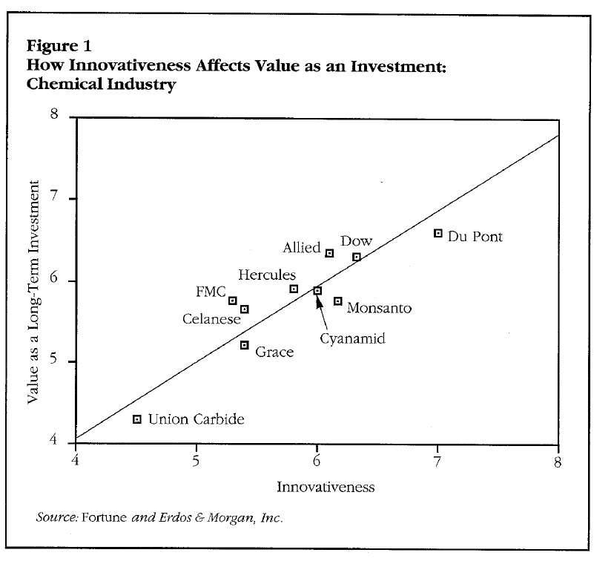

* 63 percent of managers felt that their new product success rate was disappointing or unacceptably low
* Reason
  + Too much technology push, too less market pull
  + The inability of using internal resources effectively for new product growth

## The Solution

* Management must get better at
  + Conceiving
  + Developing
  + Launching new products
  + Not just extensions and incremental improvements
    - But new products that give the firm a sustainable competitive advantage
* One major packaged goods firm
  + Always noted for its forward-thinking management methods
  + Is currently facing tougher times in its new products efforts

## The concept of a Stage=Gate System

* Stage-gate systems recognize that product innovation can be managed
  + Stage-gate systems simply apply process management methodologies to this innovation process
  + A process is subdivided into a number of stages of work stations
    - Between each work station or stage, there is a quality control checkpoint or gate
  + The stages are where the work is done; the gates ensure that the quality is sufficient
* Stage-gate system use similar methods to manage the innovation process
  + Divide the innovation process into a predetermined set of stages, themselves composed of a group of prescribed, related, and often parallel activates
* Usually stage-gate systems involve four to seven stages and gates
* Concurrently, information becomes better and better, so risk is managed
* The entrance to each stage is a gate
  + Control the process
  + Like quality control checkpoints control the production process
  + Characterized by a set of deliverables or inputs, a set of exit criteria, and an output
    - The input are the deliverables that the project leader must bring to the gate
    - Criteria are the items upon which the project will be judged, the hurdles that the project must pass at the gate to have the gate opened to the next stage
    - Outputs are the decisions at the gate, typically a Go/Kill/Hold/Recycle decision, and the approval of an action plan for the next stage
* Each project leader is required to provide the specific deliverables and meet the stated criteria at a given gate
* Gates are manned by senior managers who act a s gatekeepers
  + The gatekeeping group is typically multidisciplinary and multifunctional
  + Role include

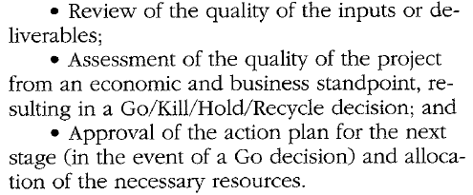

* Implementation
  + Requires certain organizational changes within some firm
    - A project team approach to organizing new product projects is fundamental to stage-gate approaches
    - The involvement of senior management as gatekeepers
      * Gate manned by senior people are not only essential to gateways systems; they build in top management involvement and commitment

## Where’s the evidence

### A quality focus

* Research suggests that quality processes are lacking in most firm’s new product programs
  + New product processes were found to be incomplete and to suffer from sloppy or under-resourced execution
* Successful products were strongly linked to quality of execution
* Several studies is convincing
  + Most product fail because of errors of omission and commission in the new product process
    - A lack of market assessment
    - Product defects
    - Inadequate launch efforts
    - Poor screening and project evaluation
  + Current performance of product innovation is far from ideal
    - There are too many missing steps and short-cuts and questionable quality of execution
  + Quality of execution separates winners from losers
  + The weakest and most pivotal activities are the predevelopment and market-oriented ones
* Stage-gate model provide the quality focus that often missing in firm’s new product programs
  + Ensure that project leaders and team meet high standards of execution
* Gates ensure that no critical activities have been omitted
  + An action plan is agreed upon at each gate, and the deliverables for the next gate are clearly specified
    - The result is no critical errors of omission, no gaps in the process, and a complete process
* Attention and resources are devoted to activities and stages that are often deficient in the innovation process
* Stage-gate system typically emphasize a market orientation and marketing inputs, and they devote far more attention to the front-end or homework stages that precede the product development phase

## A strong market orientation

* A lack of a market orientation and inadequate market assessment are consistently cited as major reasons for new product failure
  + Particularly in industrial-product and high-technology firm
* The market oriented activities tend to be the weakest in the new product process, yet they are strongly linked to success
* In successful new products had considerably more time, money, and energy devoted to market-oriented activities
* Stage-gate systems provide for a much stronger market orientation in the new product process
* The stages of the process typically include a number of market-related activities
  + User needs
  + Wants research
  + Concept tests
  + Competitive analysis
  + Development of a detailed marketing plan
  + Product tests with customers
  + Trail sell
  + Formal launch
* The project leader must ensure that these critical steps are executed
  + Unless they are, his or her project does not pass the next gate

## Better homework

* Homework is critical to successful development program
* Too many product project suffer from a lack of homework
* Activities undertaken to qualify and define the project prior to a major development program
* The most important steps of new product process
  + Lie in the stages that precede the product development phase
  + Capture the quality of execution in typical projects
  + Reveal that how well these homework stages are undertaken is strongly linked to product success
* Predevelopment activities are important because they qualify and define the project
* Stage-gate system provide a focus on homework
* The typical game plan has one or two stages devoted to predevelopment investigation
  + if this homework is not done or is done poorly, the project fails to enter the expensive development phase
* Without homework there is a much higher likelihood of new product failure
  + The choice is between a slightly longer project or increased odds of failure
* Many projects are poorly defined when they enter the development phase
  + The result of weak of predevelopment activities
    - The target user is not well understood
    - User s need and wants are vaguely defined
    - Required product features and attributes are fuzzy
* Rarely does a product concept remain the same from beginning to end
  + The original idea that triggered the project is seldom the same as what goes to market
  + Given this inevitable product design evolution
    - The time to make the majority of these design changes is not when the product is moving out of development and into production
* More homework up front encourages changes to occur earlier in the process rather than later, when they are more costly
  + The result is considerable saving in time and money at the back end of the project and a more efficient new product process

## Parallel Processing

* Parallel processing is an important feature of stage-gate system
  + Activities are parallel rather than sequential
  + At each stage of the gateways system, many activities take place concurrently and involve different functions of the firm

## Better Project evaluation

* New product resources are too valuable and scarce to misallocate
* Project evaluations, where Go/Kill and prioritization decisions are made, are critical to the proper allocation of development resources
* Stage-gate systems are designed to overcome the deficiencies in project evaluation
  + Project evaluations and bailout points are built into the process via present gates
  + Gates are characterized by a list of pre-established criteria
    - These criteria are dealing with must meet and should meet issues
  + Gates provide for top management involvement
    - Gatekeepers include the senior managers in the business unit
    - Managers can seek an immediate Go/Kill/Hold decision
    - Manager can obtain immediate approval of the needed resources

## A visible road map

* Stage-gate systems provide a road map for the project leader and team
* Stage-gate approaches lay out the suggested activities for each stage of the process
  + None of these activities is mandatory, but now the project leader has a good sense of what activities seem reasonable to consider for the next stage of the project
* Gates also provide a set of objectives for the project leader
  + The pre-specified deliverables or inputs to each gate become the objectives for the next time period
* The output of each gate help to define the project and guide the project leader
  + One of the gatekeeper is to review and approve the action plan at each gate
  + Senior managers provide suggestions and guidance to the project leader and help move the project forward

## A Typical Stage-gate system

* Idea
  + New product process is initiated by a new product idea, which is submitted to gate 1, initial screen
* Gate 1: initial screen
  + The first decision to commit resources to the project
  + A gentle screen, and amounts to subjecting the project to a handful of key, must meet and should meet criteria
* Stage 1 : Preliminary Assessment
  + The first and inexpensive stage has the objective of determine the project’s technical and market place merits
  + Involve a variety of relatively inexpensive activities
  + Purpose
    - Determine market size, potential, and acceptance
  + Gathering market and technical information, at low cost and short time
* Gate 2: Second Screen
  + Essentially a repeat of Gate 1
  + The project is revaluated, but in the light of the new information obtained in stage1
  + Subjected to the original set of must meet and should meet criteria used at gate 1
    - Dealing with scales force and customer reaction to the proposed product, the result of new data from stage 1
* Stage 2: Definition
  + The final stage prior to product development
  + Must verify the attractiveness of the project prior to heavy spending
  + The stage where the project must clearly defined
  + Market research
  + Competitive analysis
  + Market activity concept testing
  + Focus on do-ability
  + Wish list must be translated into technically and economically feasible solutions
  + Detail legal/patent/copyright work is undertaken
  + A detailed financial analysis is also conducted as an input to gate 3
* Gate 3: Decision on business case
  + The final gate prior to the development stage
  + The last point at which the project can be killed before entering heavy spending
  + Project is subjected to the set of must meet and should meet criteria
    - Qualitative side involve a review of each of the activities in stage 2
  + Concerns definition of the project
    - Agreement must be reached on a number of key items before the project proceeds into the development stage
      * Target market definition
      * Definition of the product concept
      * Specification of a product positioning strategy
      * Delineation of the product benefits to be delivered
      * Agreement on essential and desired product feature
      * Attributes
      * Specifications
* Stage 3: Development
  + Involve the development of product of detailed test, marketing, and operations plans
  + An updated financial analysis is prepared, and legal/patent/copyright issues are resolved
* Gate 4: Post-Development Review
  + A check on the progress and the continued attractiveness of the product and project
  + Development work is reviewed and checked
    - Ensuring that he work has been completed in a quality fashion
  + The test or validation plans for the next stage are approved for immediate implementation
* Stage 4: Validation
  + Test the entire viability of the project
    - Product
    - Production process
    - Customer acceptance
    - Economics of the project

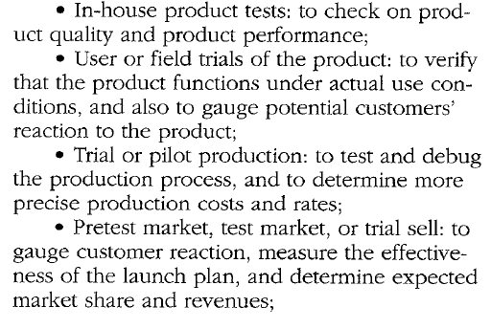

* + - Revised financial analysis
* Gate 5: Pre-commercialization decision
  + Open the door to full commercialization
  + Final point at which the project can still be killed
  + Focus on quality of the activities at the validation stage and their results
* Stage 5: Commercialization
  + Implementation of both the marketing launch plan and the operation plan
* Post-implementation review